ПРИЛОЖЕНИЕ А
Технологии создания графического пользовательского интерфейса

Задание 1. Система бронирования отеля

Листинг программы:

<Window x:Class="Task_1.MainWindow"
xmlns="http://schemas.microsoft.com/winfx/2006/xaml/presentation"
xmlns:x="http://schemas.microsoft.com/winfx/2006/xaml"
xmlns:local="clr-namespace:Task_1"
Title="Hotel Booking System" Height="650" Width="1100"
WindowStartupLocation="CenterScreen"
Background="#F8F9FA">

<Window.Resources>
<DataTemplate x:Key="RoomCardTemplate">
<Border Background="White" CornerRadius="10" Padding="15" Margin="5"
BorderBrush="#E9ECEF" BorderThickness="1">
<Border.Style>
<Style TargetType="Border">
<Style.Triggers>
<DataTrigger Binding="{Binding Status}" Value="Свободен">
<Setter Property="BorderBrush" Value="#D3F9D8"/>
<Setter Property="Background" Value="#F8FFF9"/>
</DataTrigger>
<DataTrigger Binding="{Binding Status}" Value="Забронирован">
<Setter Property="BorderBrush" Value="#FFE3E3"/>
<Setter Property="Background" Value="#FFF8F8"/>
</DataTrigger>
</Style.Triggers>
</Style>
</Border.Style>
<Grid>
<Grid.ColumnDefinitions>
<ColumnDefinition Width="*"/>
<ColumnDefinition Width="Auto"/>

</Grid.ColumnDefinitions>
<StackPanel Grid.Column="0">
<TextBlock Text="{Binding Number, StringFormat='№{0}'}"
FontSize="18" FontWeight="Bold" Foreground="#343A40"/>
<TextBlock Text="{Binding Type}" FontSize="14" Foreground="#6C757D" Margin="0,5,0,0"/>
<TextBlock Text="{Binding Price, StringFormat={}{0:0} ₽/ночь}"
FontSize="14" Foreground="#5C7CFA" Margin="0,5,0,0"/>
</StackPanel>
<Border Grid.Column="1" CornerRadius="15" Padding="10,5" VerticalAlignment="Top">
<Border.Style>
<Style TargetType="Border">
<Style.Triggers>
<DataTrigger Binding="{Binding Status}" Value="Свободен">
<Setter Property="Background" Value="#D3F9D8"/>
</DataTrigger>
<DataTrigger Binding="{Binding Status}" Value="Забронирован">
<Setter Property="Background" Value="#FFE3E3"/>
</DataTrigger>
</Style.Triggers>
</Style>
</Border.Style>

Анализ результатов:
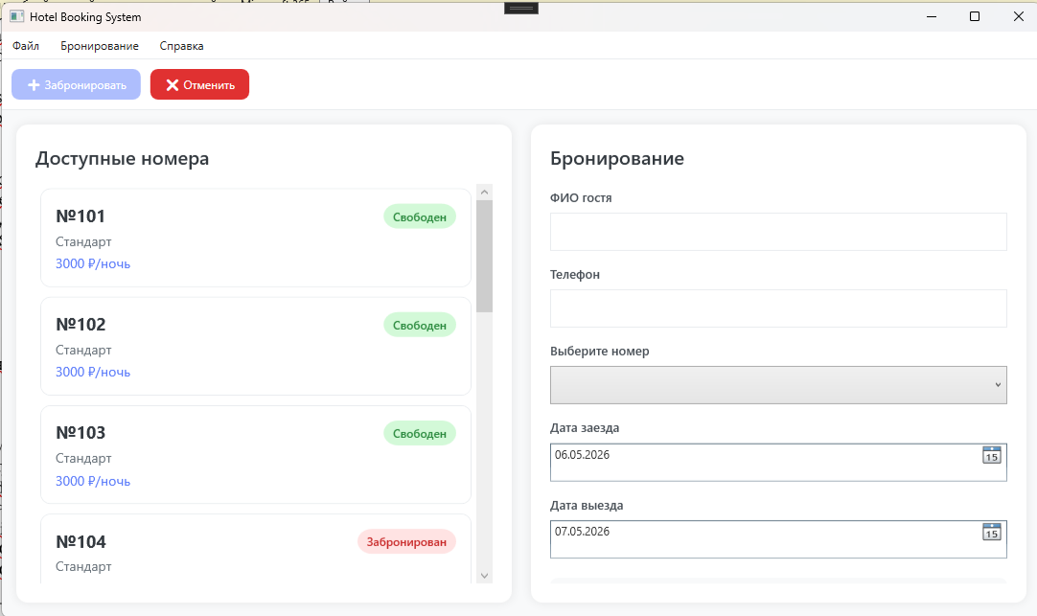
Рисунок 1.1 – Результат работы программы

